CURRICULUM VITAE

Professor Josep Tornero is from Valencia, Spain in 1956. He received his B.Sc. and his Ph.D. in Electrical Engineering at the Technical University of Valencia in 1978 and 1985, respectively. In 1982, he obtained his M.Sc. Degree in Systems and Control at the University of Manchester, Institute of Science and Technology. In 1986, he was promoted to Associate Professor and since 1993, has been Full Professor at the Department of Systems Engineering and Control (Technical University of Valencia).

For two years (1981-1983), he was Visiting Researcher at the Control Systems Center of the University of Manchester, Institute of Science and Technology (UMIST). In 1990, he spent an academic year as Visiting Researcher at the NASA Center for Intelligent Robotics Systems for Space Exploration (CIRSSE), Rensselaer Polytechnic Institute in Troy, New York, USA. In 1999, he spent an academic year as Visiting Professor at the Department of Mechanical Engineering, University of California at Berkeley, USA.

In 1984, he was appointed Vice Director of the Computer Science Faculty, in addition to being Head of Studies from 1985 to 1989. From 1992 to 1993, he was appointed Vice Dean of the same Faculty. In 1994, Professor Tornero was appointed the Secretary General (Registrar) of the Technical University of Valencia (UPV), and from 1995 to 1996 he was Vice Chancellor. Currently, he is the Director of the Institute of Design and Manufacturing at the UPV.

From 1993 to 1995, Professor Tornero was elected as a member of the Spanish Robotic Association Board, and is also a member of IEEE, IFAC and DECUS.

He is the Director of the post-graduate program in Master of Science in Computer Aided Design (CAD), Computer Aided Manufacturing (CAM) and Computer Integrated Manufacturing (CIM), in progress since 1988.

In terms of technology transfer, a prototype of inspection tunnel based on artificial vision for quality control of automobile painted bodies was designed and successfully tested in production line for several years at the Ford Factory in Almussafes (Valencia), inspecting more than 1500 cars each day. Afterwards, industrial inspection systems have been installed, first in the Ford factory at Genk, Belgium and Almussafes, Spain, and during 2012 at two inspection tunnel at the Ford factory of Dearborn close to Detroit and two other inspection tunnels at the Ford factory of Kentucky. And in 2012, Prof. Tornero was honored with the Henry Ford Technology Awarded 2012.

Professor Tornero’s current research interests are in robotics and automation, particularly in three areas: collision detection and avoidance, automatic trajectory generation, and control for robot arms and mobile robots. He also conducts research on multi-rate sampled data systems in the aspects of modeling, analysis and control design.

He has given lectures, seminars and presented many papers on control topics such as multi-rate sampled data systems, digital control and periodic systems, as well as robotics topics such as modeling, collision detection and avoidance, path planning, automatic generation of trajectories and control architectures.

Professor Tornero has authored 50 research articles, 5 books and 9 book chapters. He also holds 3 patents in artificial vision applied to detection and surveillance.

He acts as a research mentor and is currently advising 3 PhD students, 5 postdoctoral associates, and 2 research scientists/visiting scholars. And in previous years, he has tutored more than 15 PhD Thesis and 40 M.Sc. Thesis.

He has participated in European research projects such as ESPRIT, BRITE, EUREKA and STRIDE, and in educational projects as ERAMUS, INTERCAMPUS, ALPHAS and TEMPUS.

He is fluent in English, understands French, likes gardening, music, and regularly practices sports such as jogging, cycling and swimming. Professor Tornero is married and has two children.

Prof. Josep Tornero
___________________________________________________________

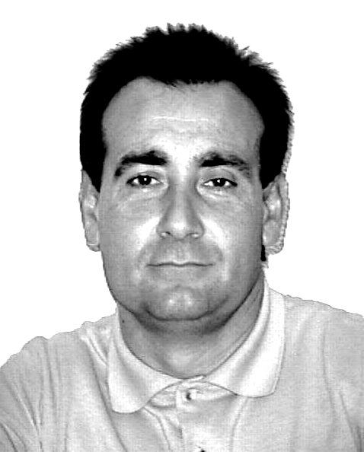 | Josep Tornero was born in Valencia, Spain in 1956. He received in 1982 the M.Sc. Degree in Systems and Control from the University of Manchester, Institute of Science and Technology and in 1985 the Ph.D. in Electrical Engineering at the Technical University of Valencia, where his is now Full Professor with the Department of System Engineering and Control. He has been Visiting Researcher at the CIRSSE (NASA Center for Intelligent Systems for Space Explorations, Rensselaer Polytechnic Institute, Troy, New York during 1990 and Visiting Professor at the Mechanical Engineering
Department, University of California at Berkeley, during 1999. Professor Tornero is the Head of the Robotics Group, mainly concerned with the integration, programming, control, simulation and management of robot arms and auto-guided-vehicles (AGVs). He is particularly interested in three topics: collision detection and avoidance, trajectory generation and control, and artificial vision. He is also doing research on multirate sampled data systems in the aspects of modeling, analysis and control design. He has participated in many European research projects such as ESPRIT, BRITE, EUREKA and STRIDE, and in educational projects as ERAMUS, INTERCAMPUS, ALPHAS and TEMPUS. He is a Member of the Institute of Electric and Electronics Engineers (IEEE) and International Federation of Automatic Control (IFAC). Now he is also the Director of the Design and Manufacturing Institute which involves a research center and an enterprise association. Reserach

